Name:______________________________________ Date: ____________ Period: ____
Lesson 2.1.1 Homework Day 1 Problems 2-8 to 2-12
2-8. How many tenths are in one whole? How many hundredths?

2-9. Convert the following fractions to decimals. Show your work.

2-10. Mario ordered a pizza for dinner. When it arrived, Mario quickly ate of the pizza. While Mario was getting napkins, his pet poodle ate of the pizza.
a) Draw a model of the pizza that shows the portion that has been eaten.

b) Write a numerical expression to show the fraction of the pizza that is left.

c) About what percent of the pizza is left?

2-11. Nicole has a machine that will produce a number from 1 through 50 when she pushes a button. If she pushes the button, what is:
a) P(multiple of 10)? b) P(not 100)?

c) P(not a mutliple of 4)? d) P(one-digit number)

2-12. Lyle and his study team are designing spinners.
a) If one half of the sections on a spinner are green and there are 14 sections, how many are green?

b) If three fourths of the sections on a different spinner have stripes and there are 24 sections, how many sections have stripes?

Name:______________________________________ Date: ____________ Period: ____
Lesson 2.1.1 Homework Day 2 Problems 2-13 to 2-17
2-13. Which of the fractions listed below will have repeating decimals and which will have terminating decimals? Explain how you know.
a) b) c) d)

2-14. Here are the lengths (in inches) of snakes in a reptile display at the zoo: 10, 31, 36, 36, 38, 42, 47, 48, 49, and 52. Find the mean and median of the lengths.

Mean:___________________ Median: ___________________
2-15. Thomas has a bag with 7 green marbles, 5 blue marbles, and 4 red marbles. For each part below, if the marble selected is replaced before the next marble is drawn, find the probability for the given draw. Write your answer as a fraction, as a decimal, and as a percent.
a) A red marble?

Fraction: ____________ Decimal:________________ Percent: _____________
b) A red or a green marble?

Fraction: ____________ Decimal:________________ Percent: _____________
c) An orange marble?

Fraction: ____________ Decimal:________________ Percent: _____________
2-16. Finding patterns is an important problem-solving skill used in mathematics. You will use the patterns in Diamond Problems to solve other problems later in the course. Can you discover a pattern for the numbers in each of the four diamonds below?
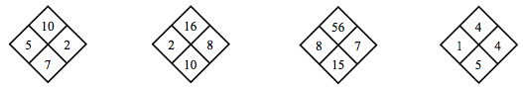
Use the pattern you discovered to complete each of them.
a) 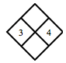 b) 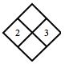 c) 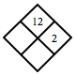 d) 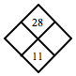

2-17. Read the Math Notes box for this lesson. Then rewrite each number below as a single fraction greater than one.
a) b) c)

